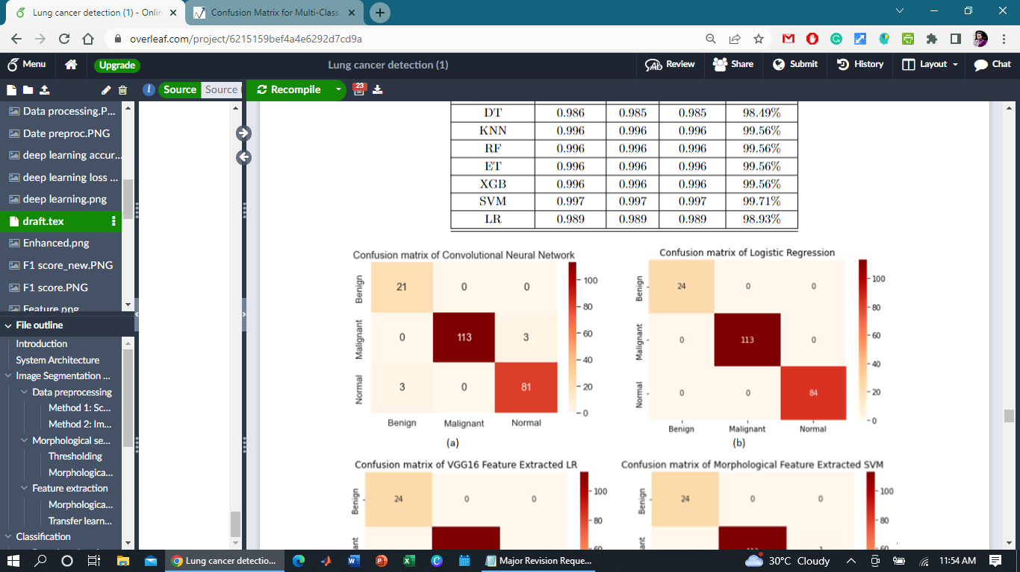

For Our Case;

Y- Axis = Predicted Value

X- Axis = Actual Value

**Benign Case:**

**TP (True Positive)**:

The actual value of the Benign Case.

So, TP = 21

**FP (False Positive):**

The sum of values of corresponding rows except the TP value

FN = (cell 2 + cell3)

= (0 + 0)

= 0

**FN (False Negative):**

The sum of values of corresponding column except the TP value.

FP = (cell 4 + cell 7)

= (0 + 3)

= 3

**TN (True Negative):**

The sum of values of all columns and row except the values of that class that we are calculating the values for.

TN = (cell 5 + cell 6 + cell 8 + cell 9)

= 113 + 3 +0 + 81

= 197

**Precision Formula:**

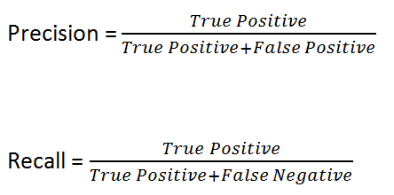

Precision = 21/ (21+0) = 1.0

Benign Precision = 1.0



**Malignant Case:**

**TP (True Positive)**:

The actual value of the Malignant Case.

So, **TP = 113**

**FP (False Positive):**

The sum of values of corresponding rows except the TP value

FN = (cell 4 + cell6)

= (0 + 3)

= 3

**FN (False Negative):**

The sum of values of corresponding column except the TP value.

FP = (cell 2 + cell 8)

= (0 + 0)

= 0

**TN (True Negative):**

The sum of values of all columns and row except the values of that class that we are calculating the values for.

TN = (cell 1 + cell 3 + cell 7 + cell 9)

= 21 + 0 +3 + 81

= 105

**Precision Formula:**



Precision = 113/ (113+3) = 0.974137931



**Normal Case:**

**TP (True Positive)**:

The actual value of the Malignant Case.

So, **TP = 81**

**FP (False Positive):**

The sum of values of corresponding rows except the TP value

FN = (cell 7 + cell 8)

= (3 + 0)

= 3

**FN (False Negative):**

The sum of values of corresponding column except the TP value.

FP = (cell 3 + cell 6)

= (0 + 3)

= 3

**TN (True Negative):**

The sum of values of all columns and row except the values of that class that we are calculating the values for.

TN = (cell 1 + cell 2 + cell 4 + cell 5)

= 21 + 0 +3 + 113

= 105

**Precision Formula:**



Precision = 81/ (81+3) = 0.9642857143

Weighted Precision = ((1 * Total Benign Sample) + (0.974137931* Total Malignant Sample) + (0.9642857143 * Total Normal Sample)) / Total Sample

= ((24*1) + (0.974137931*113) + (0.9642857143*84)) / 221

= (24 + 110.0775862 + 81) / 221

=0.9732017475

Reference: <https://www.analyticsvidhya.com/blog/2021/06/confusion-matrix-for-multi-class-classification/>